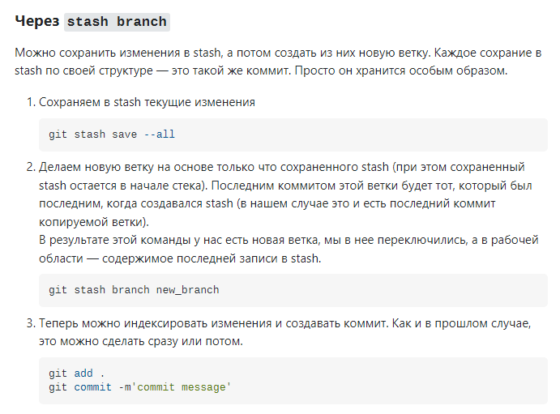

Через stash branch

Можно сохранить изменения в stash, а потом создать из них новую ветку. Каждое сохрание в stash по своей структуре — это такой же коммит. Просто он хранится особым образом.

1. Сохраняем в stash текущие изменения
2. git stash save --all
3. Делаем новую ветку на основе только что сохраненного stash (при этом сохраненный stash остается в начале стека). Последним коммитом этой ветки будет тот, который был последним, когда создавался stash (в нашем случае это и есть последний коммит копируемой ветки).  
   В результате этой команды у нас есть новая ветка, мы в нее переключились, а в рабочей области — содержимое последней записи в stash.
4. git stash branch new_branch
5. Теперь можно индексировать изменения и создавать коммит. Как и в прошлом случае, это можно сделать сразу или потом.
6. git add .

git commit -m'commit message'

Zed@DESKTOP-JV16M7C MINGW64 ~/Desktop/Train (k2)

$

* History restored

Zed@DESKTOP-JV16M7C MINGW64 ~/Desktop/Train (k2)

$ git status

On branch k2

Your branch is up to date with 'origin/k2'.

Changes not staged for commit:

(use "git add <file>..." to update what will be committed)

(use "git restore <file>..." to discard changes in working directory)

modified: pages/main/index.html

modified: pages/main/style.css

Untracked files:

(use "git add <file>..." to include in what will be committed)

nav-bundel/

no changes added to commit (use "git add" and/or "git commit -a")

Zed@DESKTOP-JV16M7C MINGW64 ~/Desktop/Train (k2)

$ git stash save --all

warning: LF will be replaced by CRLF in nav-bundel/bundle.js.

The file will have its original line endings in your working directory

Saved working directory and index state WIP on k2: d7d5842 feat: update nav-background__picture

Zed@DESKTOP-JV16M7C MINGW64 ~/Desktop/Train (k2)

$ git stash branch new_feature

Switched to a new branch 'new_feature'

On branch new_feature

Changes not staged for commit:

(use "git add <file>..." to update what will be committed)

(use "git restore <file>..." to discard changes in working directory)

modified: pages/main/index.html

modified: pages/main/style.css

Untracked files:

(use "git add <file>..." to include in what will be committed)

nav-bundel/

no changes added to commit (use "git add" and/or "git commit -a")

Dropped refs/stash@{0} (b4fc3bdd63ef155f7ed26d7318a37bdec9278b08)

Zed@DESKTOP-JV16M7C MINGW64 ~/Desktop/Train (new_feature)

$ git status

On branch new_feature

Changes not staged for commit:

(use "git add <file>..." to update what will be committed)

(use "git restore <file>..." to discard changes in working directory)

modified: pages/main/index.html

modified: pages/main/style.css

Untracked files:

(use "git add <file>..." to include in what will be committed)

nav-bundel/

no changes added to commit (use "git add" and/or "git commit -a")

Zed@DESKTOP-JV16M7C MINGW64 ~/Desktop/Train (new_feature)

$ git add .

Zed@DESKTOP-JV16M7C MINGW64 ~/Desktop/Train (new_feature)

$ git status

On branch new_feature

Changes to be committed:

(use "git restore --staged <file>..." to unstage)

new file: nav-bundel/bundle.js

modified: pages/main/index.html

modified: pages/main/style.css

Zed@DESKTOP-JV16M7C MINGW64 ~/Desktop/Train (new_feature)

$ git commit -m'feat: add dropdown menu AND add adaptive'

[new_feature 14adf9a] feat: add dropdown menu AND add adaptive

3 files changed, 657 insertions(+), 44 deletions(-)

create mode 100644 nav-bundel/bundle.js

Zed@DESKTOP-JV16M7C MINGW64 ~/Desktop/Train (new_feature)

$ git push

fatal: The current branch new_feature has no upstream branch.

To push the current branch and set the remote as upstream, use

git push --set-upstream origin new_feature

Zed@DESKTOP-JV16M7C MINGW64 ~/Desktop/Train (new_feature)

$ git push --set upstream origin new_feature

error: src refspec origin does not match any

error: failed to push some refs to 'upstream'

Zed@DESKTOP-JV16M7C MINGW64 ~/Desktop/Train (new_feature)

$ git push --set-upstream origin new_feature

Enumerating objects: 13, done.

Counting objects: 100% (13/13), done.

Delta compression using up to 8 threads

Compressing objects: 100% (6/6), done.

Writing objects: 100% (8/8), 4.62 KiB | 2.31 MiB/s, done.

Total 8 (delta 2), reused 0 (delta 0), pack-reused 0